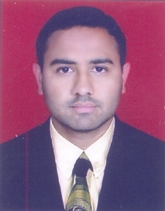

NAME:-WADGHULE GAURAV SARJERAO
EMAIL:- gwadghule456@gmail.com
Mob.No:- 9960313262
CAREER OBJECTIVE
To utilize the best of my abilities, knowledge and skills in research to improve the Quality for well being humanity.
Desire to work in collaborative and motivated team environment.

PERSONAL INFORMATION
Name :- WADGHULE GAURAV SARJERAO
Date of Birth :- 2-6-1993
Permanent address :- Plot no-64,flat no-3,Apexa appartment
near jatra hotel,Adgaon, Nashik-3
Marital Status :- Unmarried
Gender :- Male
Nationality :- Indian
Languages known :- Marathi, English and Hindi.
EDUCATIONAL QUALIFICATION
EXAMINATION | UNIVERSITY | PASSING YEAR | PERSENTAGE
M.Sc | Pune | 2017 | 61.18%
B.Sc | Pune | 2014 | 73.53%
H.S.C | Nashik division | 2011 | 59.33%
S.S.C | Nashik division | 2009 | 77.53%
PROGRAMS ATTENDEND
1) Chemical Science-Challenges and Opportunities

STREANGTH
1) Possessing good communication skill.
2) A self starter with a Positive attitude.

EXTRA ACTIVITIES
1) NCC

HOBBIES
1) Playing chess

COMPUTER KONWLEDGE
1) Certificate Course On Computer Concepts

DECLARATION
I hereby declare that the above written particulars are true to the best of my knowledge and belief.

Date: / / 2017
Place: Nashik Yours Sincerely,
(Mr. Wadghule Gaurav Sarjerao)

