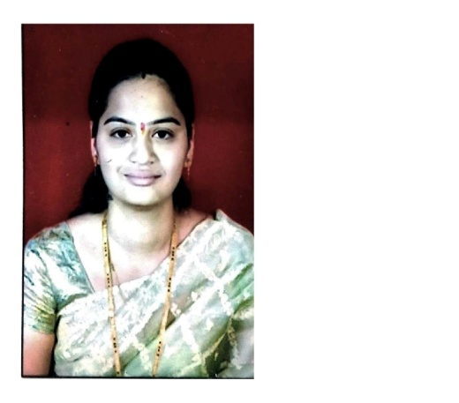
VADJE JYOTI NIVRUTTI

Department: Electrical Engineering Designation: Technical Assistant
(SOFTWARE LAB)
Date of joining: JULY 2015
Mobile No: 9637748777
Email id: jnvadje@kkwagh.edu.in
Educational Qualification: B E (Computer Engineering)

Language known: Marathi, Hindi, English, Sanskrit

Place: Nasik Vadje Jyoti N

Date: 14/10/2021 Technical Assistant

Electrical Engineering Department

K.K.W.I.E.E. & R, Nashik.

