K.K. Wagh Institute of Engineering Education & Research
Department of Civil Engineering

Bio Data

1. | Name: | : | 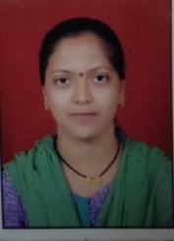  Ravina Onkar Khaire
2 | Address: |  | Flat no 17, Rajnisagar appt, mangalmurti nagar,  bhodhale nagar nashik 422011
3 | Date of Birth |  | 29/01/1994
4 | Phone No. | : | 8485000832.
5 | Email | : | rokhaire@kkwagh.edu.in
6 | Educational Qualification: | : | BSC Chemistry
7 | Date of Joining In Institute | : | 15/07/2019
8 | Designation | : | Technical Assistant.
9 | Workshop / Seminar attended | : | No
10 | IT Proficiency  ❖ MS – CIT | : | MS-CIT

