K. K. Wagh Institute of Engineering Education and Research
Department of Production Engineering
Technical News Letter
November 2021 of AY 2021-22
It’s a great pleasure to present our newsletter for the November of AY 2021-22. Department of Production Engineering has been consistently endeavoring to upgrade the skills and performance of students and staff members through various ventures.

- Online Training Completed by faculty
02 Online Training Completed by faculty
Sr. No. | Name of faculty | Designation | Training Name | Conducted By
1 | A.S. Kamble | Assistant Professor | AICTE Training And Learning (ATAL) Academy Online Elementary FDP on "Reinforcement Learning and its Applications" from 08/11/2021 to 12/11/2021 | Indian Institute of Technology Ropar.
2 | M. Y. Khalkar | Assistant Professor | Two Weeks Live Online Industrial Training Program On Artificial Intelligence & Machine Learning Using Python held during 15 - 26 November 2021 | Finland Labs (A Unit of Revert Technology Pvt. Ltd., New Delhi)

- Online Panel Discussion
Department of Robotics and Automation organized Panel discussion on "Career Opportunities in Robotics and Automation” on 15th November 2021. The speaker of this panel discussion are Mr. Ravi Mahadeokar (Managing Directot Strama Summit Machinery Pvt. Ltd; Nashik), Mr. Nilesh Nikam ( Assistant Manager Industrial Program Leader Fourecia Clean Mobality, Pune), Mr. Vinod Atpadkar ( CEO SVR Infotech, Pune), Mr. Vinay Kunwar ( Director India First Robotics Innovation & Reaserch LLP, Pune) & Mr. Surinder sigh Narula ( Managing Director Axiomatic iTech Pvt Ltd; Ahmadabad). The speakers of this panel discussion explored the application of robots in manufacturing as well as in service organization. They also explained about the role and importance of robots in automobile Industry.
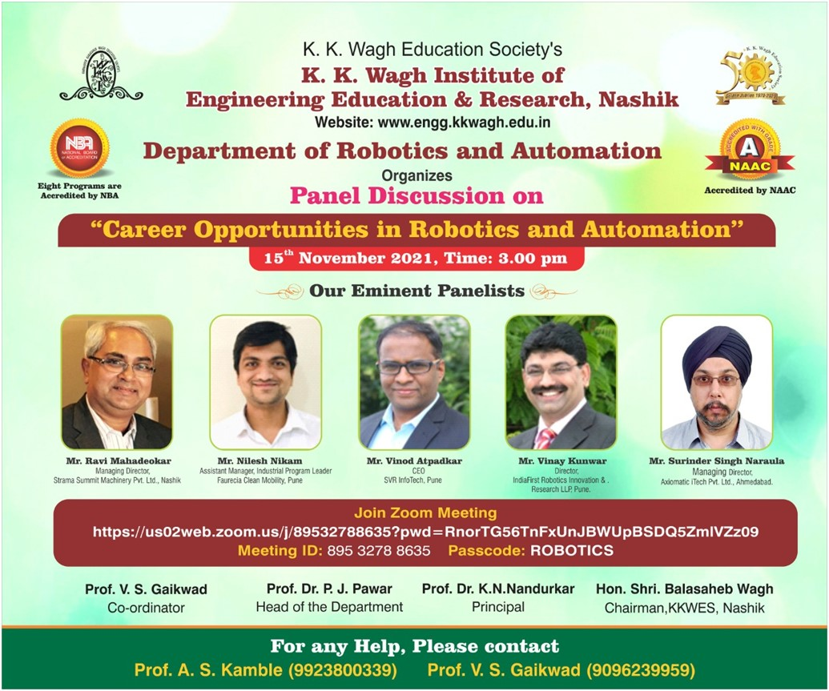

Online Webinar attended by the faculty
In the month of the November 2021 teaching and non- Teaching staff member attended various webinar on online platform to explore the new advancement in the technology.

- Student Achievement
01 student of 2021-2022 batch select in TCS with package of 3.3 lacs.

- Staff Activities
Expert lectures delivered:
- Dr. P. J. Pawar delivered expert session at Air Force Nashik for their officers on topic “Occupational Safety and Health: A case study of drill Manufacturing” on 22nd Nov. 2021.
Dr. P.J. Pawar
Head of the Department

