 | The Civilians
The department is committed to the advancement of the healthy academic culture and a symbiosis between the teachers and students. Different activities are conducted in the department for guiding the students in various fields and to nurture the students in their Skills.  VISION OF DEPARTMENT  Imparting quality technical education in civil engineering for infrastructural development and meeting the needs of society. |  | MISSION OF THE DEPARTMENT  - M1: To develop Civil Engineers having knowledge, attitude, skills and who can effectively serve the needs of society.  - M2: To mould the Civil Engineering graduates to become global leaders who will lead the eco-friendly construction for sustainable development.  - M3: To inculcate the work culture and ethics among the Civil Engineering graduates for planning, designing and execution of construction project with quality and economy. | “You are not here merely to make a living. You are here in order to enable the world to live more amply, with greater vision, with a finer spirit of hope and achievement. You are here to enrich the world.”  By:  Woodrow Wilson (28th President of US)  Just by saying the words one may motivate the person for short duration. But to keep this motivation for life time, our teachers work hard n smart.  Our Vision and Mission is also based on imparting the skills, ethics and of course knowledge.

VISITS ARRANGED

To enhance the imagination skills and for clear understanding of subject, Visits are very much important. It helps students to understand the actual application of theory topics on field.

Railway station visit was arranged to clear the doubts of students regarding different terminologies related to Railway.

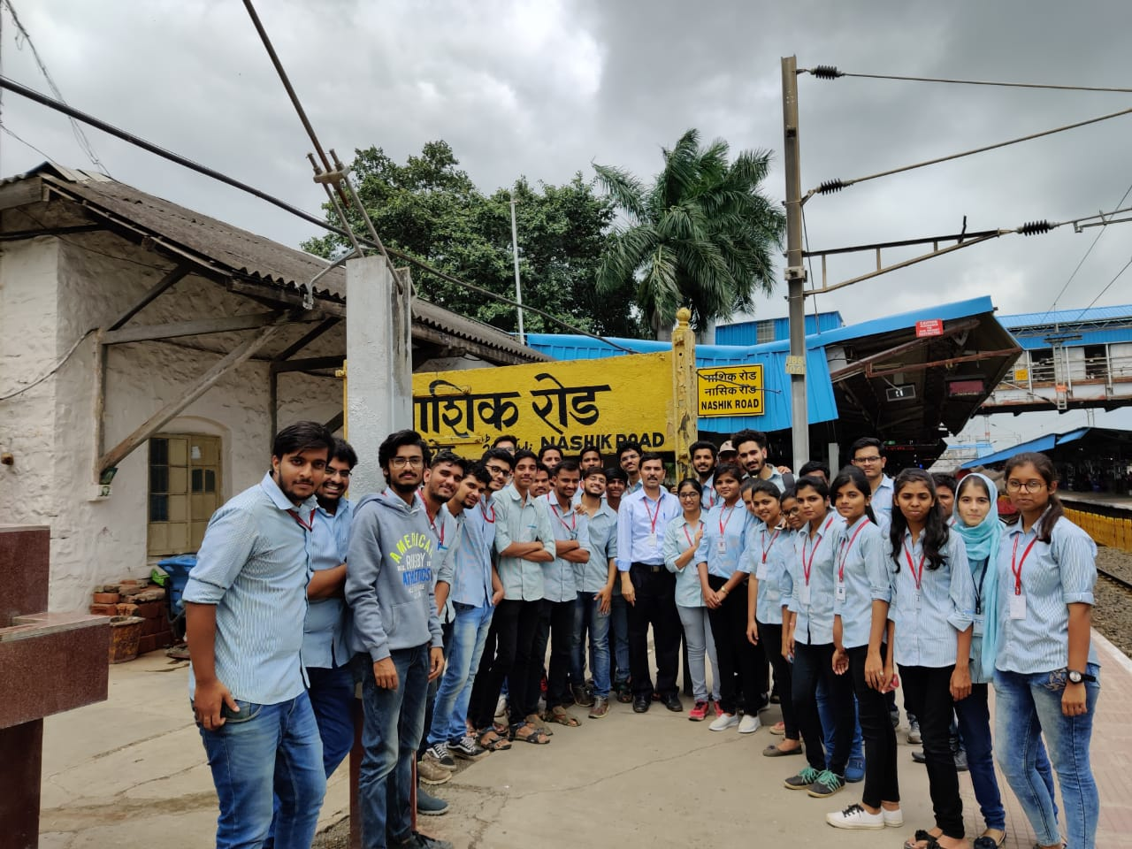

Visit to Nashik Road Railway Station TE-I on 28/08/2019

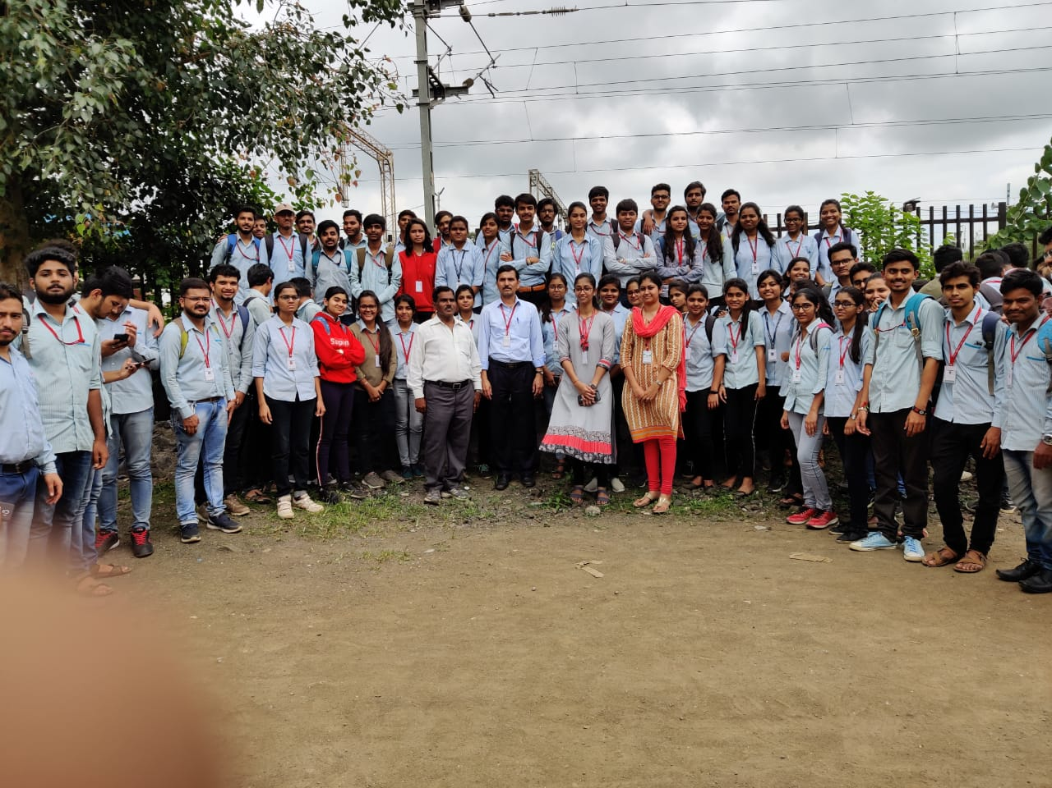

Visit to Nashik Road Railway Station TE-I on 28/08/2019

Expert’s DESK
Experts of the field can better teach the topic to budding civil engineers. Its need of an hour to teach the advanced techniques to the students. It makes the students Field ready.
Expert’s talks are arranged in department to enhance the knowledge and skills of budding civil engineers. The extra topics which are important in terms of the advanced knowledge are covered in expert talks. Beyond syllabus topics are also covered in this so that students get the knowledge about recent trend in field. | GIS (Geographical Information System):  A geographic information system (GIS) is a framework for gathering, managing, and analyzing data. Rooted in the science of geography, GIS integrates many types of data. It analyzes spatial location and organizes layers of information into visualizations using maps and 3D scenes. |  | “Develop a passion for learning. If you do , you never cease to grow.”
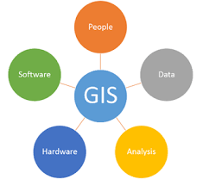 |  | ESRI : Environmental Systems Research Institute) is an international supplier of Geographical Information System (GIS) software, web GIS and geodatabase management applications. It is the global market leader in GIS since 1969. It started ArcGIS, the world’s most powerful mapping and spatial analytics software. As it believes that the location intelligence can unlock data’s full potential in every organization. It helps the users to Combine information, find patterns, and make connections.
Geological Information System

Industrial Training

Continuous learning is one of the keys to success in life. No matter what you do. Learning, wisdom and success are three things that fit together hand-in-glove.

Based on this fact, all the faculty members of the department undergo the industrial training in vacation period. Environmental Engineering, Structural Engineering, Building Materials and Planning Aspects etc., are the identified areas for training. In this academic year, 15 faculty members have successfully completed the training in various industries.
Such training helps the faculty members to update themselfe regarding the lattest knowledge on field, so that the same knowledge can be shared with students to make them industry ready.

Industrial training is compulsory for the students of Third year. Construction industries selected by staff are allocated to the students. Students has to undergo the 15 days training in allotted industry. It helps the students to check the application of theory knowledge on field and makes the students industry ready.

