K.K. Wagh Institute of Engineering Education & Research
Department of Civil Engineering

1. | Name of Teaching Staff | Dr. Dhake Pravinchandra D. |  | 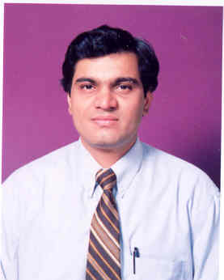
2. | Contact Number | (+91)-9423185180
3. | Email | pddhake@kkwagh.edu.in
4. | Designation | Professor
5. | Date of Joining the Institution | 1st Jan. 2000
6. | Qualification with Subject and Class/Grade | - Ph.D. Civil Engineering, SVNIT, Surat  - M.E. Structures, Govt. College of Engg. Karad, Distinction  - B.E. Civil Engineering, SPPU, First Class
7. | Total Experience | Teaching | 18.5 Years
8. | Subject Teaching | - Structural Design II (T.E.)  - Structural Design III (B.E)  - Structural Dynamics (M.E. Structures)  - Finite Element Method (M.E. Structures)
9. | Consultancy | - Design of Ground Storage Reservoirs, Elevated storage Reservoirs, R.C.C. and Steel Structures.  - Third Party Checking of Structural Designs.  - Concrete Mix. Design, NDT  - Testing of all construction materials and concrete members.
8. | Papers Published | International | 08
 |  | National | 00
9. | Papers Presented in Conferences | International | 11
 |  | National | 03
10. | Professional Memberships | - Institution of Engineers (IE)  - Indian Society for Technical Education (ISTE)  - Association of Architects and Engineers, Nashik  - Institution of Engineering and Technology (IET)  - Association of Consulting Civil Engineers (ACCE)

