K. K. Wagh Institute of Engineering Education and Research
Department of Production Engineering
Technical News Letter
December 2021 of AY 2021-22
It’s a great pleasure to present our newsletter for the December of AY 2021-22. Department of Production Engineering has been consistently endeavoring to upgrade the skills and performance of students and staff members through various ventures.

- Expert lectures attended by staff
01 expert lectures attended by the teaching and non- Teaching staff.
Sr.No. | Title of lecture | Name of Speaker | Name of Industry | Date | No. of Student Present
1 | Advanced Product Quality Planning | Mr. Pradip Sharma, | JP Enterprises, Nashik | 14-12-2021 | 36
- Online Training Completed by faculty
05 Online Training Completed by faculty
Sr. No. | Name of faculty | Designation | Training Name | Conducted By
1 | N. B. Gurule | Associate Professor | Industry 4.0 & IOT: Opportunities and Challenges during 16 - 18 December 2021 | Karmaveer Adv. B. G. Thakare College of Engineering, Nashik
2 | A.S. Kamble | Assistant Professor | Advances in Control Systems & Sensor Technologies during 27/11/2021 to 01/12/2021 | AICTE Training And Learning (ATAL) Academy at Indian Institute of Information Technology Pune.
3 | A.S. Kamble | Assistant Professor | Essentials of Machine Learning during 13/12/2021 to 17/12/2021 | AICTE Training And Learning (ATAL) Academy at Centre for Development of Advanced Computing (CDAC). Noida
4 | A.S. Kamble | Assistant Professor | Recent Trends and Advancements in ANN and Deep learning for Real Time Applications during Dec. 20-12-21 to 24-12-21. | AICTE Training And Learning (ATAL) Academy at RCET, Bhilai
5 | R.V. Jadhav | Technical Assistant | Material Camp, during 28 - 31 Dec.2021 | ASM International, India chapter & KK Wagh IEE & R Nashik

- Industrial Visits
01 Industry visited by Staff & Students.
Sr. No. | Date | Name of Industry | Name of staff visited to industry
1 | 24/12/2021 | Sahyadri Farm, Mohadi, Dindori, Nashik | No. of Students visited 50  Staffs visited 04

Department of Robotics & Automation and Production Engineering Organized Value added course in Association with KKWIEE&R Idea lab on CNC Programming 10/12/2021 to 10/01/2022

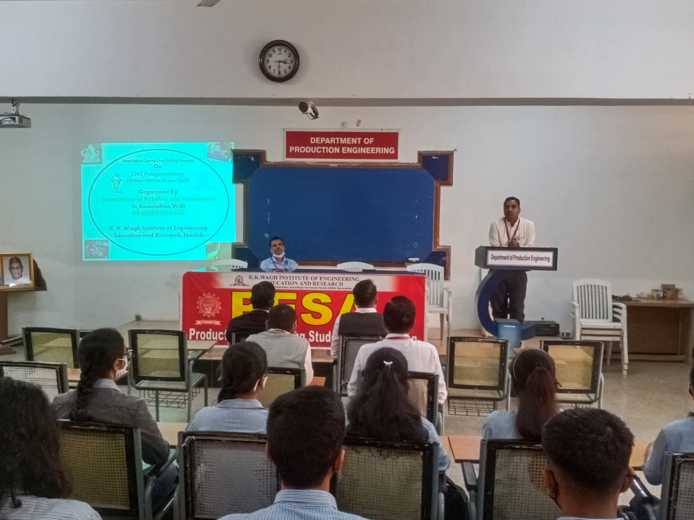

Online Webinar attended by the faculty
In the month of the December 2021 teaching and non- Teaching staff member attended various webinar on online platform to explore the new advancement in the technology.

- Student Achievement
11 students of 2020-2021 batch and 04 students of 2021-2022 Batch were selected in various companies with package of 2.4 lacs to 4.5 lacs. Felicitation Program for these placed students was organized by Production Engineering Department on 31st Dec 2021. 35 students along with staff attended this program

- Staff Activities
Expert lectures delivered:
Dr. K. N. Nandurkar delivered expert talk on 'Genetic algorithm and Particle swarm optimisation' at Atal FDP organised by Govt. Polytechnic, Nashik Date: 15th Dec. 2021.
Dr. P. J. Pawar delivered expert talk on 'Genetic algorithm and Particle swarm optimisation' at Atal FDP organised by Govt. Polytechnic, Nashik Date: 13th Dec. 2021.

Dr. P.J. Pawar
Head of the Department

