K.K. Wagh Institute of Engineering Education & Research
Department of Civil Engineering

1. | Name of Staff | Mr. Bhushan P. Chumble |  | 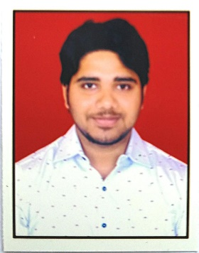
2. | Contact Number | (+91)-9271061418
3. | Email | bpchumble@kkwagh.edu.in
4. | Designation | Technical Assistant
5. | Date of Joining the Institution | 8th September 2021
6. | Qualification with Subject and Class/Grade | - B.Tech in Civil Engineering.
7. | Total Experience in Years | Industry | 1 Years
 |  | Teaching | 00 Year
8. | Papers Published | International | 00
 |  | National | 01
9. | Papers Presented in Conferences | International | 00
 |  | National | 00
10. | Professional Memberships | Nil
11. | Interaction with Professional Institutes | Nil
12. | Workshop/ STTP/ FDP/ Conference Attended | Nil

