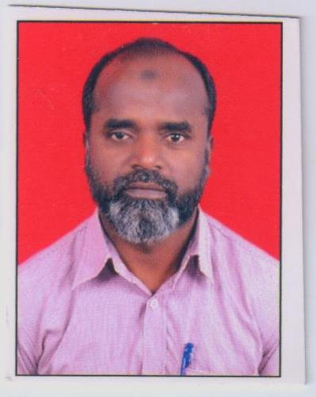
BIODATA
Name:- Ansari Abdul Wadood Mohammad Haroon
DOB:- 11th May 1970
Official Address:- K. K. Wagh Institute of Engg. Education and Research, Nashik
Email:- ahansari@kkwagh.edu.in
Education-Qualification:-
Sr.No | Degree | Year | University | Class Obtained
1 | B.Sc | 1992 | SPPU | Ist Class
2 | M.Sc. | 1994 | SPPU | Ist Class
3 | Ph.D(IITB) | 2015 | I.I.T. Bombay | NA
4 | B.Ed | 1998 | SPPU | Ist Class
Employment Record:-
Sr.No | University/Employer | Designation | Period
1 | K. K. Wagh Institute of Engineering Education & Research Panchavati Nashik 03 | Asstt. Professor | 4th June 2001 Till date
2 | Y.E.W.S. National College Nashik | Lecturer | June 1995-1999

Publication:-
1. A. K. Singh; A. W. M. H. Ansari (2010) Synthesis of uniform narrow-size nanoparticles of cholesterol esters using hydrophobicity and microemulsion. Nanosci. Nanotechnol. Lett. 2, 46-50.
2. A. K. Singh and A. W. M. H. Ansari (2016) Fluorescent organic nanoparticles of 3-styrylindoles - synthesis and characterization. J. Nanosci. Nanotechnol. 17, 1381-1386.
3. Singh, A. K. and A.W.M.H. Ansari (2014) Synthesis and characterization of fluorescent organic nanoparticles. In 8th CRSI –RSC Joint Symposium (February 06, 2014) and 16th CRSI National Symposium in Chemistry (February 07-09, 2014), Department of Chemistry, IIT Bombay.
4. Singh, A. K. and A.W.M.H. Ansari (2010) Synthesis and characterization of uniform narrow-size nanoparticles of cholesteryl esters using hydrophobicity and microemulsion In In-House symposium (February 27, 2010), Department of Chemistry, IIT Bombay.

Books – NIL
Paper Presented - NIL
Training Programme Attended:-
Sr.No. | Programme | Organized By | Period
1 | STTP on Recent trends in processing of particulate Matter. | V.I.T. (Vellore) | 8 -21 June2003
2 | STTP on Innovations in food processing and preservation & future research needs. | M.P.U.Ag.Tech.(Udaipur) | 22 Dec.2003- 4 Jan 2004

Conference Attended :-
Sr.No. | Conference On | Organized By | Period
1 | Seminar on Expectations of Industries from academia | K.T.H.M College | 18 Dec. 2004
2 | Seminar on Demystifying E-learning | C-DAC New Bombay | 26 Feb. 2005
3 | National, International and Conferences | I. I. T. Bombay | 2006 – 2008
Workshop Attended:-
Sr.No. | Workshop On | Conducted By | Period
1 | Work shop on Environmental awareness and pollution Control (EAPC) | K.K.W.I.E.E.R. Nashik | 26 July 2004
2 | Work shop on Rain water harvesting | K.K.W.I.E.E.R. Nashik | 23 May 2003
3 | Seminar on Expectations of Industries from academia | K.T.H.M College | 18 Dec. 2004
4 | Seminar on Demystifying E-learning | C-DAC New Bombay | 26 Feb. 2005

Area of Interest:-Synthesis Characterization and Application of Fluorescent Organic Nanoparticles in different media

signature
(Dr. Ansari A.W.M.H.)

