K.K. Wagh Institute of Engineering Education & Research
Department of Civil Engineering

1. | Name of Teaching Staff | Akanksha Vivek Pisolkar |  | 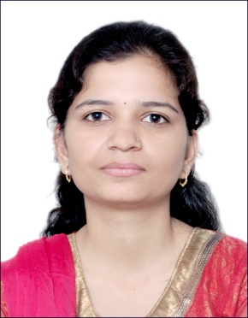
2. | Contact Number | (+91)-9637519600
3. | Email | avpisolkar@kkwagh.edu.in
4. | Designation | Assistant Professor
5. | Date of Joining the Institution | 19th August 2014
6. | Qualification with Subject and Class/Grade | - M.E. Structural Engineering, SPPU, First Class with distinction  - B.E. Civil Engineering, SPPU, First Class with distinction
7. | Total Experience in Years | Industry | 0.0 Years
 |  | Teaching | 5.0 Years
8. | Papers Published | International | 00
 |  | National | 00
9. | Papers Presented in Conferences | International | 00
 |  | National | 00
10. | Professional Memberships | Nil
11. | Interaction with Professional Institutes | Nil

