Summary of Bangalore Visit by K K Wagh Team
K K Wagh team of following seven members visited Bangalore during 25th to 30th November-2016 for attending HR Meet/Alumni Meet and Visit to corporate offices.
- Er. Sameer B Wagh , Hon. Trustee of K K Wagh Education Society, Nasik
- Prof K S Bandi, Hon Secretary K K Wagh Education Society, Nasik
- Dr.K N Nanndurkar, Principal, K K Wagh Institute of Engineering Education and Research-Nasik
- Dr. S S Sane HOD Computer, K K Wagh Institute of Engineering Education and Research-Nasik
- Dr B E Kusahre HOD Electrical, K K Wagh Institute of Engineering Education and Research-Nasik
- Dr. P K Shahabadkar, TPO, K K Wagh Institute of Engineering Education and Research-Nasik
- Prof. U K Gaikwad, Faculty, IT Department K K Wagh Institute of Engineering Education and Research-Nasik
HR Meet
The HR Meet was held on 25th November in Taj West End Hotel, Bangalore with an objective of providing a platform for an interaction between K K Wagh and industry representatives of Bangalore. The focus was on enhancing the existing relations and connecting with new industries. The idea was to get the inputs from industry leaders for enhancing capabilities of our students and making them more employable.
Participants from Manufacturing, IT as well as Service Sector attended this meeting. Some of the prominent members were from BOSCH, HAL, Winjit, TMEIC, UE Development India Pvt Ltd, KPIT Technologies, ABS India Pvt Ltd, Astutix Learning Pvt Ltd, Balpharma and Element 14, Professional bodies like IIPE and IET were also represented by their office bearers.
The program started with the registration between 6.30 to 7.00 PM followed by welcome speech and presentation by Principal, Dr.K.N.Nandurkar. He shared the details about K K Wagh Education Society and its institutes, facilities available, academic performance and achievements of students, research and consultancy works carried out by institutes. This was followed by presentation of documentary on K K Wagh IEER and Power Point Presentation by TPO, Dr P K Shahabadkar about Industry-Institute Interaction at K K Wagh. He shared the objectives of HR Meet in Bangalore, K K Wagh Training Model for students, Placement Policy and Placement Statistics, areas of mutual cooperation and academic performance of students available for the campus interview in 2016-17. Subsequently all managers expressed their views for bridging the skill gap. This HR meet was summarized by Dr S S Sane and vote of thanks was proposed by Dr. B E Kushare
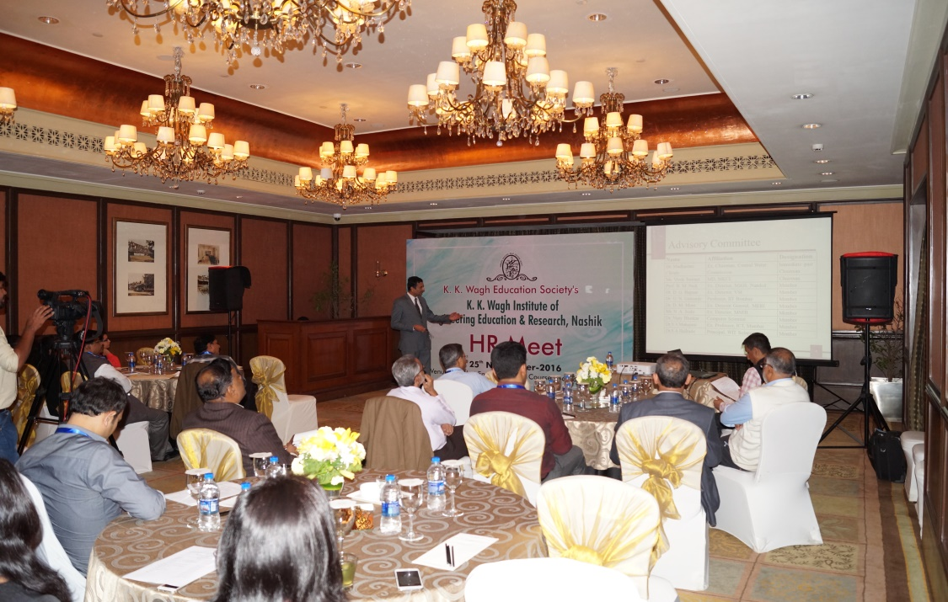
Picture 1: Presentation by Dr. K N Nandurkar
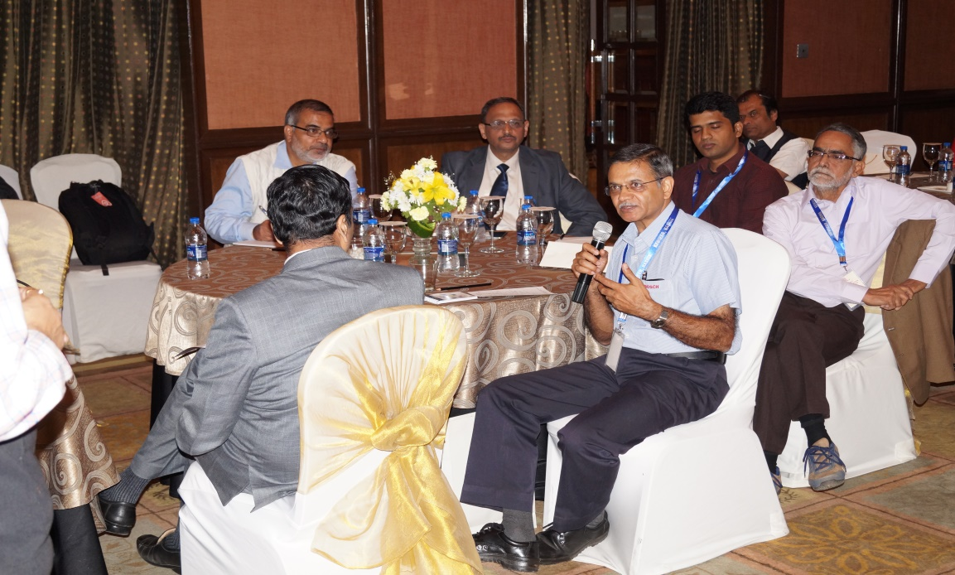
Picture 2: Views by Participants

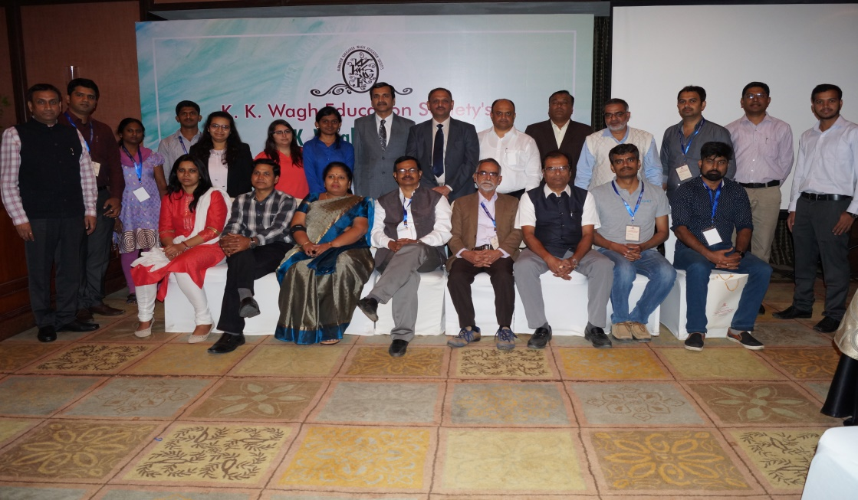
Picture 3: Group Photo of HR Meet
Alumni Meet
Alumni Meet was held on 26th November in The President Hotel, Bangalore and it was attended by 51 Alumni from earlier batch of passed out during 1990 to 2016.
The program started with the registration between 6.30 to 7.00 PM followed by welcome speech and presentation by Principal, Dr.K.N.Nandurkar. This was followed by presentation of documentary on K K Wagh Education Society, K K Wagh IEER and Power Point Presentation by Dr S S Sane. He shared the objective of Alumni meet in Bangalore and probable areas of mutual cooperation.
Subsequently Alumni members expressed their views and introduced themselves and shared their experiences while studying in K K Wagh. Alumni meet was summarized by Dr B E Kushare and vote of thanks was proposed by Dr. Pramod Shahabadkar. Many alumni members have expressed their interest to help the institute in the areas like: Delivering Expert lectures, Placement, Career counseling and Training to students
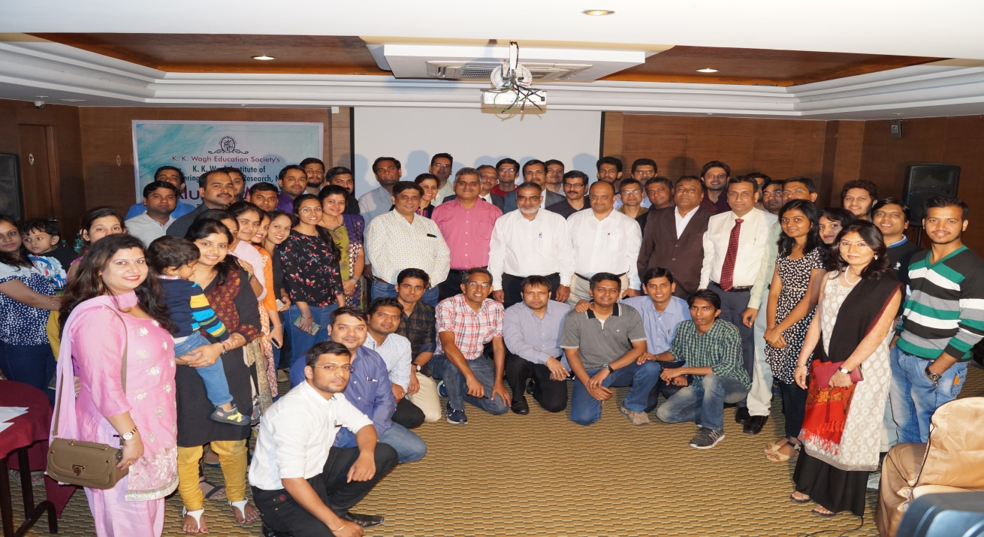
Picture 5: Group Photo of Alumni Meet
Visit to Corporate Offices in Bangalore
Visit to corporate offices were held during 28th to 30th Novemeber-2016 by two teams of K K Wagh. In all they visited 11 corporate offices with an objective of enhancing interactions. These includes: IBM, EPCOS, Times Group, CGI, Oracle, VMWARE, Schneider R&D Canter, Mindtree, ABB, Amazon and Ashok leyland.
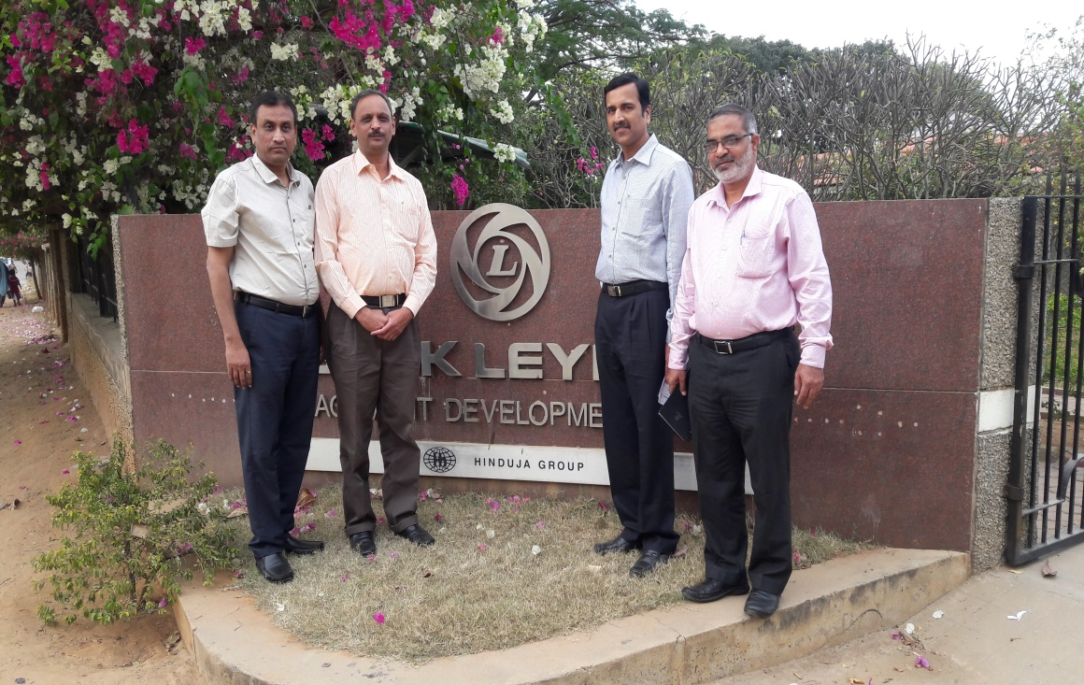
Visit to Ashok Leyland

