Resume
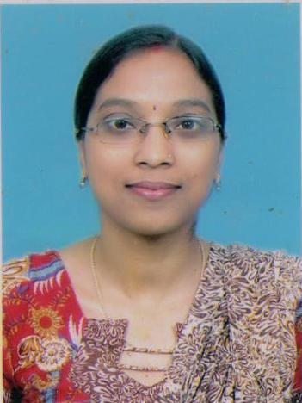
Ms. Archana Lalchand Mourya.
[ M.Sc.(Mathematics),NET,SET,B.Ed.]

OBJECTIVE:
M.Sc.(Mathematics)

To provide the best with technical abilities, skills & strength honestly and sincerely to the organization associated with.
CONTACT INFORMATION
Email : archana1704@gmail.com
Phone No. : (0253)2452065/9860283438
Current Residence : 30,Sahane Mala, opp. To Fernandes Wadi,Jaibhavani
Road,Nashik Road.
PERSONAL INFORMATION

Name : - Archana Lalchand Mourya.
Father Name : - Lalchand Baburam Mourya.
Permanant Address : -.30,Sahane Mala, opp. To Fernandes Wadi,Jaibhavani
Road,Nashik Road.
Date of Birth :- 17th April 1983 Gender :- Female
Nationality :- Indian
WORK EXPERIENCE:

1)K.K.Wagh College of Agricultural Engg & Tech., Nashik.
Lecturer From 11th July 2006 t0 31st july 2007

2)K.K.Wagh Institude of Engineering Education & Research., Nashik
Lecturer From 1st August 2007 till date

PROFETIONAL QUALIFICATION

Examination | Discipline / Specialization | College | University | Year of passing | Percentage
M.Sc. | Mathematics | K.T.H.M. College , Nashik | PUNE. | 2005 | 80.45%
B.Sc. | Mathematics | Bytco College,Nashik Road. | PUNE. | 2003 | 85%
B.Ed. | ------ | College Of  Education  Nashik | PUNE | 2006 | 67.75%

EDUCATIONAL BACKGROUND

Qualification | Year of passing | University / Board | School / College | Marks (%)
S.S.C. | March 1998 | Maharashtra State Board | Sri Jairambhai Vidyamandir,Nashik Road. | 70.8
H.S.C. | February 2000 | Maharashtra State Board | Bytco College,Nashik Road. | 72.5

Workshop Attended:-
Sr.No. | Workshop On | Conducted By | Period
1 | State level Workshop on Research Methothodology | Department of Computer Engg. K.K.W.I.E.E.R., | August 23rd,24th 2013
2 | Enginering Mathematics III(Revised syllabus 2012 Course) | K.K.W.I.E.E.&R., Nasik & Board of Studies (Engg. Sciences) University of Pune | 18th December 2013
3 | Latex Workshop(Spoken Tutorial) | K.K.W.I.E.E.&R.,Nasik | 28 July 2012

Training Programme Attended:-

Sr.No. | Programme | Organized By | Period
1 | ISTE approved STTP “Effective Teaching Learning Tools” | Lokhande Gopinathji Munde Institute of Engineering Education & Research, Nasik | 20th to 24th December 2016

LANGUAGE KNOWN:

English, Hindi, Marathi

