K. K. Wagh Institute of Engineering Education & Research, Nashik
ISTE Students’ Chapter
Academic Year 2015-16

Sr. No. | Name of the Event | Date
1 | Guest Lecture by Dr. Ajinkya Patil on “Gender Equality” | 04-08-2015
2 | Guest Lecture by Swami Nityananda on “Vedanta and Science” | 19-08-2015
3 | Guest lecture by Prof. Naik and installation of new committee | 22-08-2015
4 | Poster Competition on the topic “Vision 2020” | 09-09-2015
5 | Guest lecture on “Social Media and Networking” by Mr. Eknathji Satpurkar | 23-09-2015
6 | State level elocution competition “Vijigisha” | 07-01-2016
7 | Master Student Program at K. K. Wagh Institute of Engineering Education & Research, Nashik | 11-03-2016
8 | Master Student Program at Guru Gobind Singh College of Engineering, Nashik | 22-03-2016
9 | Srinivasa Ramanujan Mathematics Competition Zonal and National Round | 27-03-2016 &  09-04-2016

- Guest Lecture by Dr. Ajinkya Patil on Gender Equality

On Tuesday, 4th Aug. 2015 ISTE Stdents’ Chapter in association with NSS had organized expert talk on “Gender Equality and Women Safety” by Dr. Ajinkya H. Patil (Ph. D. from Groningen University, Netherland and Coordinator Youth Program, Anti Dowry Movement, India).

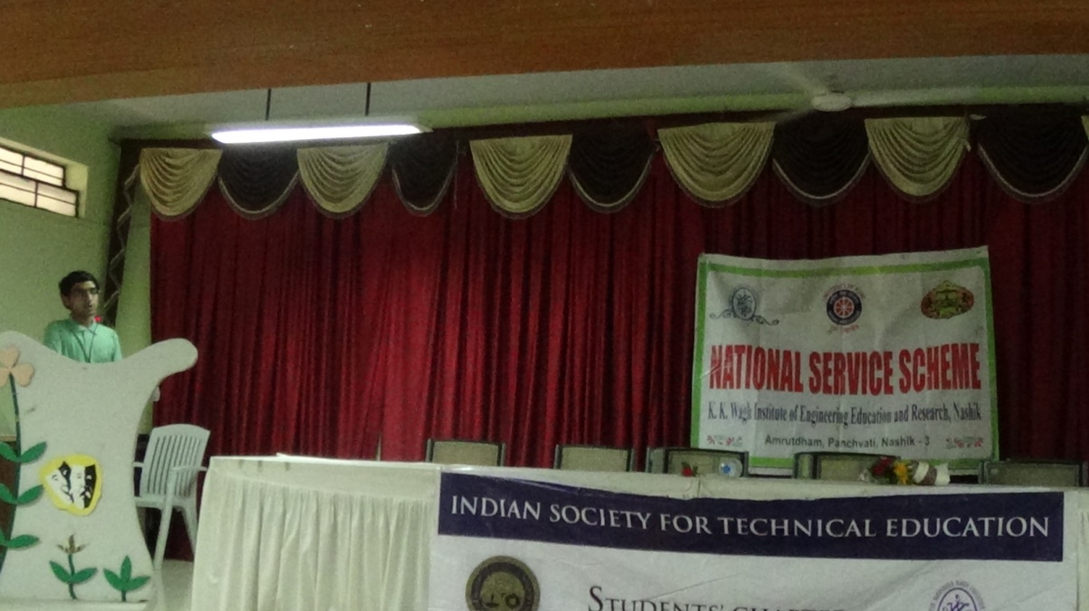

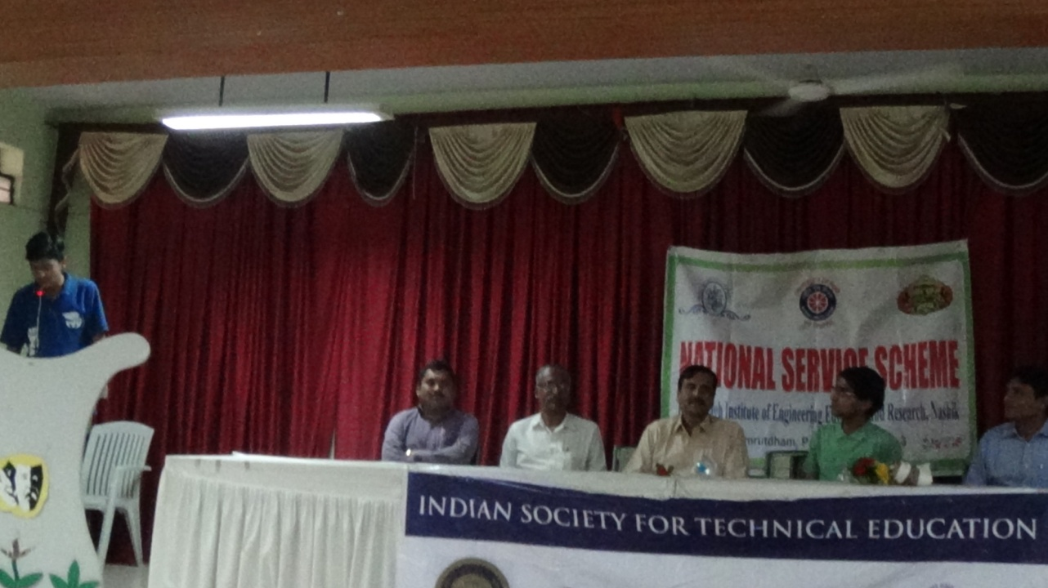
From L to R : Prof. N.B.Gurule, Prof. Dr. Kute, Prof. Dr. K.N.Nandurkar, Dr. A.H. Patil

- Guest Lecture by Swami Nityananda on “Vedant and Science”

On Wednesday, 19th Aug. 2015 ISTE Students’ Chapter in association with NSS has organized an expert lecture on topic “Vedant and Science” by Swami Nirbhaynanda (Famous Spiritual Guru and Religious Speaker). In this event Swami Nirbhayananda felicitated to all the members of student Council.

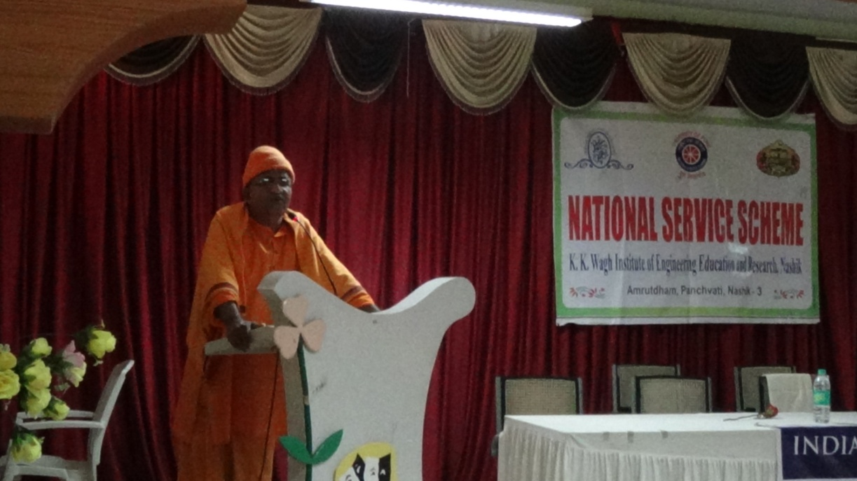
Swami Nirbhayananda

- Guest lecture by Prof. Naik and installation of new committee

The ISTE Students’ Chapter committee for the academic year 2015-16of K. K. Wagh Institute of Engineering Education and Research was officially inaugurated in the presence of honourable chief guest Prof. B. M. Naik, Principal Dr. K. N. Nandurkar, T&P Officer Dr. P. K. Shahabadkar and ISTE Students’ Chapter faculty advisor Prof. P. S. Vispute. The event was held on 22nd of August and was attended by the first and second year students.

Dr. Nandurkar expressed his views on ISTE Students’ Chapter and appritiate the previous committee for conduction of various activities throughout the year. Prof. Vispute then briefed about the events conducted by ISTE Students’ Chapter in the last academic year. Following this, the winners of the Ramanujan Mathematics Competition at national and zonal level were awarded. The Ramanujan Mathematics Competition is an annual event organized by ISTE Students’ Chapter which aims at finding the ingenious mathematicians hidden among not only students but also the teachers.

Prof B. M. Naik, past Principal of Guru Gobind Singh College of Engineering, Nanded, and also the past President of ISTE, Maharashtra and Goa region, enlightened the students on what innovation is and how it goes hand in hands with different career paths. He explained the importance of leadership qualities among the students and gave them valuable career guidance.

After Prof. Naik’s precious guidance, the paramount part of the event began – felicitation of the current and the new ISTE Students’ Chapter committee. ISTE Students’ chapter Committee for academic year 2015-16 is President: Devanshi Dattani, Vice President: Shubham Mahajan, Treasurer: Surbhi Sachdev, Co-Tresurer: Sanuja Kulkarni Secretary: Ashish Metkar, Co-Secterory: Anuttama Wagh and core committee members were felicitated by the chief guest.

The event was concluded with a vote of thanks by the ex-president of ISTE Students’ Chapter, Shubham Gawande.

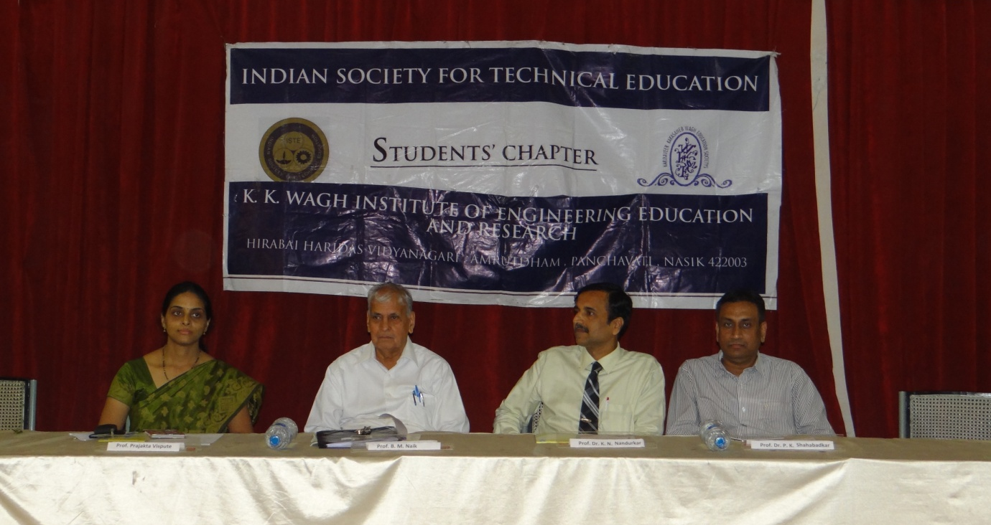
From L to R : Prof. P. S. Vispute, Prof. B. M. Naik, Prof. Dr. K. N. Nandurkar, Prof. Dr. P. K. Shahabadkar
- Poster Competition on the topic “Vision 2020”

In the memory of past president Bharatratna Dr. APJ Abdul Kalam, an intercollegiate poster making competition was organized in K. K. Wagh Institute of Engineering Education and Research, Nashik by ISTE students’ chapter.
A tribute was paid to Dr. APJ Abdul Kalam by the participants by making posters on the theme “VISION 2020”- a book written by him. The competition was organized on 9th and 10th September 2015 under the guidance of Dr. K. N. Nandurkar, Principal, K.K.W. I. E. E. R. this competition was open for all regular Diploma, UG and PG students. Around 158 posters were received. Due to the overwhelming response, in addition to regular three prizes, additional three consolation prizes were also awarded by the committee.
The prize distribution ceremony was held on 9th sept 2015. For this function chief guest Dr. B. G. Wagh, Principal, KSKW Arts, Science and Commerce college, CIDCO, Nashik with Dr. K. N. Nandurkar, Principal, K.K.W. I. E. E. R., and Prof. Prajakta Vispute, Faculty Advisor, ISTE students’ chapter were present. Dr. B. G. Wagh appreciated the concept and creativity of the participants and suggested to prepare the booklet of these posters for further reference. The posters were judged by Prof. Sahane and Prof. Nagarkar. The prize winners were as follows:
First Prize :Rajkamal Rathod & Tejal Dere (Rs. 1500/-)
Second Prize: Mayuri Rajole & Madhuri Tade (Rs. 1000/-)
Third Prize: Mansi Talele & Ananya Nandi (Rs. 750/-)
First Consolation Prize: Priyanka Shinde (Rs. 500/-)
Second Consolation Prize: Akansha Nandanwar & Mayuri Sonje (Rs. 500/-)
Third Consolation Prize: Shweta Mate & Pratiksha Paluskar (Rs. 500/-)

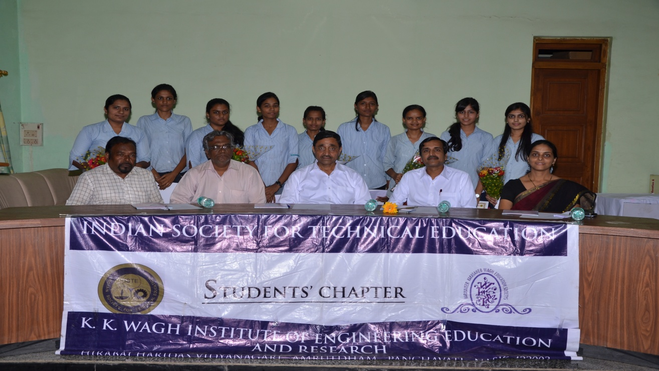
From L to R : Prof. Nagarkar, Prof. N. M .Shahane Prof. B. G. Wagh, Dr. K. N. Nandurkar, Prof. P. S. Vispute

- Guect lecture on “Social Media and Networking” by Mr. Eknathji Satpurka

An expert talk by Hon. Shri. Eknath Satpurkar on the topic “Social Media and Networking” was organised by the ISTE Students’ Chapter of K. K. Wagh Institute of Engineering Education and Research. For this event Hon. Shri. Balasaheb Wagh,Chairman K.K.Wagh Education Society, Dr. K. N. Nandurkar ,Principal, Dr. S. S. Sane, Vice Prinvipal, K. K. Wagh Institute of Engineering Education & Research and Prof. P. S. Vispute Faculty Advisor ISTE Students’ Chapter, Principals of other institutes and HOD’s of different departments alomg with many keen students were present for the program.
Mr. Eknath Satpurkar, who has been the regional minister of Sanskar Bharati for a period of 6 years, an experienced director and the founder of the production house, Arusha Creations was felicitated by Hon. Shri. Balasaheb Wagh . A short video film which featured numerous social workers and their compassionate work for the society was presented before the audience, followed by Hon. Eknath Satpurkar addressing the audience.
He briefed the audience about the work he has been carrying out since years. Eknathji has documented the work of several social workers and organizations spread all across India, who work in extremely remote areas and their work has been going unnoticed for years. His motivation behind this documentation was that ordinary people should be aware of the generous work that these altruistic social workers have been carrying out. He appealed the audience to at least visit these workers some time and appreciate them for the kind work that they do. "Paying them a visit is a sign of appreciation, which will encourage them to work more enthusiastically", said Eknath Satpurkar.
He also emphasized on the potential of a powerful tool like media, to bring in light such noble acts which deserve recognition and appreciation. While concluding his speech, he appealed the youth by saying, "We all owe something to the society, and we must pay it back, one way or the other."
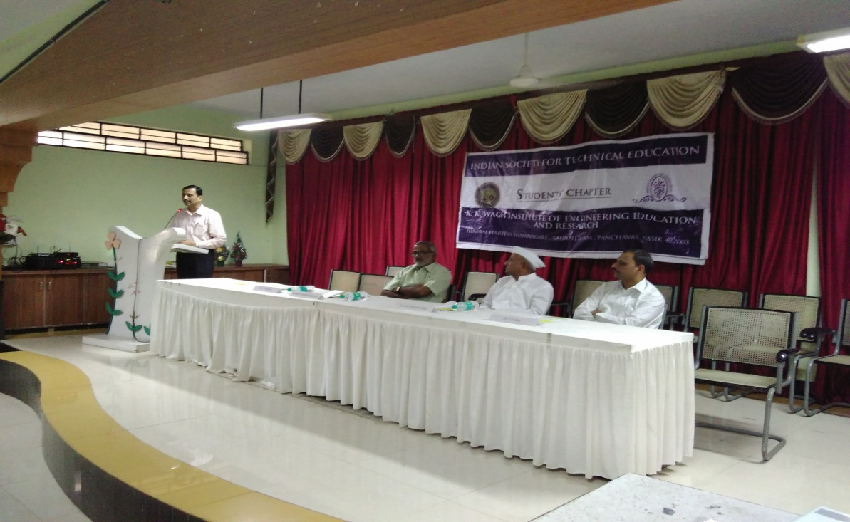
From L to R : Prof. Dr. K. N. Nandurkar, Mr. Eknath Satpurkar, Hon. Shri. Balasaheb Wagh, Prof. Dr. S. S. Sane
- State level elocution competition “Vijigisha”

A state level intercollegiate elocution competition, ‘Vijigisha 2015-16’ was organized by ISTE Students Chapter of K. K. Wagh Institute of Engineering Education and Research, Nashik on 7th January, 2016. The Competition was organized in two languages English & Marathi and received a great response of around 125 participants.
The competition was inaugurated in the morning by Dr. K. N. Nandurkar, Principal and Dr. S.S.Sane, Vice Principal, K.K.Wagh Institute of Engineering Education and Research, Nashik. The Judges for English category were Prof. S. R. Kulkarni, Mr. A. K. Dixit, Ms. Usha Kiran Pishreddy and Mrs. Yogita Bhamare and those in Marathi category were Mrs. Anagha Kulkarni and Dr. Asmita Deshpande.
The Prize distribution ceremony was conducted in the evening. Mrs. Vrinda Bhargave was the chief guest for the function, she appreciated the afforts in taken in organizing the competition and said that such platforms were necessary for the students to showcase and polish their speaking skills Mr.Vinay Kataria and Ms. Irene Francis and Ms. Deepa Pokar secured the 1st and 2nd prizes respectively in the English Category .Ms. Chinmayee Shaligram and Ms. Devanshi Dattani grabbed the consolation prizes.
In the Marathi Category Ms. Mahima Thombre and Mr. Mahesh Kedar secured the 1st and 2nd prizes respectively and Mr.Prasanna Bacchav and Mr. Rahul Mahajan grabbed the consolation prizes.
ISTE faculty advisor P.S. Vispute and ISTE students’ chapter students took efforts to conduct the event successfully.

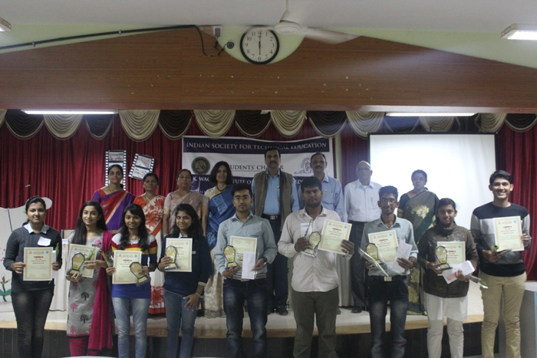
From L to R: Prof. P. S. Vispute, Mrs. Dr. Asmita Deshpande, Anagha Kulkarni, Mrs. Vrinda Bhargave, Prof. Dr. K. N. Nandurkar, Prof. Dr. S. S. Sane, Prof. S. R. Kulkarni, Ms. Usha Kiran Pishreddy with the winners of competition

- Master Student Program at K.K.Wagh Institute of Engineering Education & Research, Nashik
The Master Student Program is organized every year in K. K. Wagh Institute of Engineering Education and Research by ISTE student’s chapter since 2003 and this year it marked its 14th year of success. It was conducted on 9th March 2016. This program is inspired by a book called “Master Student” prepared by ISTE. The theme usually revolves around the development of technical and non technical skills that an engineering student needs to inculcate in his life.
The theme of this year’s Master Students Program was “ENGINEER’s ARSENAL” introduced by principal of the institute Dr.K.N.Nandurkar. The program focuses on different skills an engineering student should acquire during four years of course to mould himself/herself as a world class professional. This theme is broadly classified into fourteen subtopics which were presented by fourteen students selected from various department of second year engineering as a speaker. They were mentored by a group of fourteen students from third year for a period of nearlytwo weeks. The speakers delivered a short presentation, each concentrating on the various facets of the given theme.
Prof. Dr. K. N. Nandurkar and Prof. Dr.S. S. Sane graced the event with their presence. Prof. Vijay Bhat, Principal MET BKC Polytechnic, Nashik guided students about his journey and the importance of hard and soft skills in Engineers life. The program was conducted for the entire day and it provided an entire spectrum of topics which includes 7 Hard and 7 Soft Skills, right from “Listening skills” to “Introspection” and “People skills”. It was aimed at helping not only the first year engineering students but the second, third and fourth year students to think out of the box. So, they can consider these factors for their great and successful future. The team of ISTE under the guidance of their Principal Dr.K.N.Nandurkar and faculty advisor Prof. Prajakta Vispute marked this year’s MSP as a remarkable and successful event.

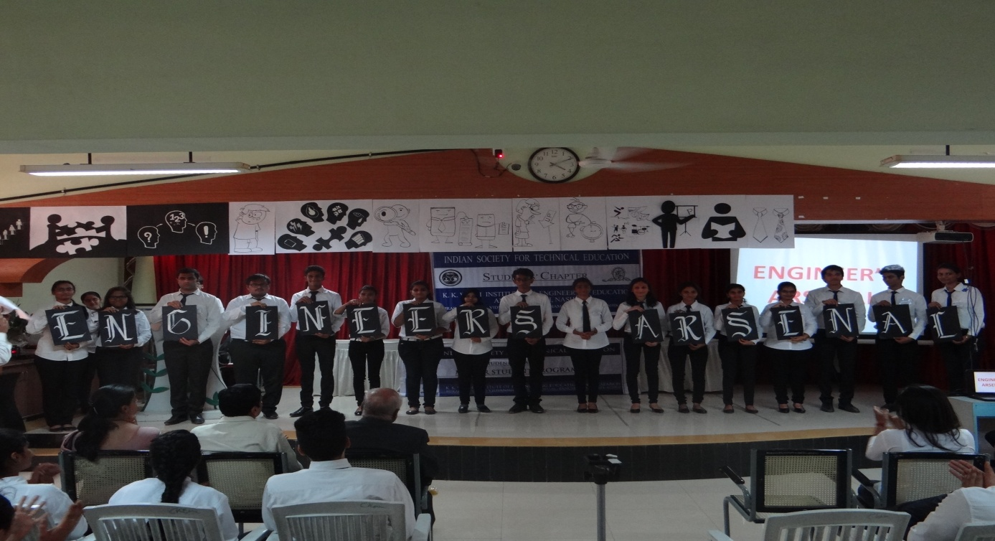

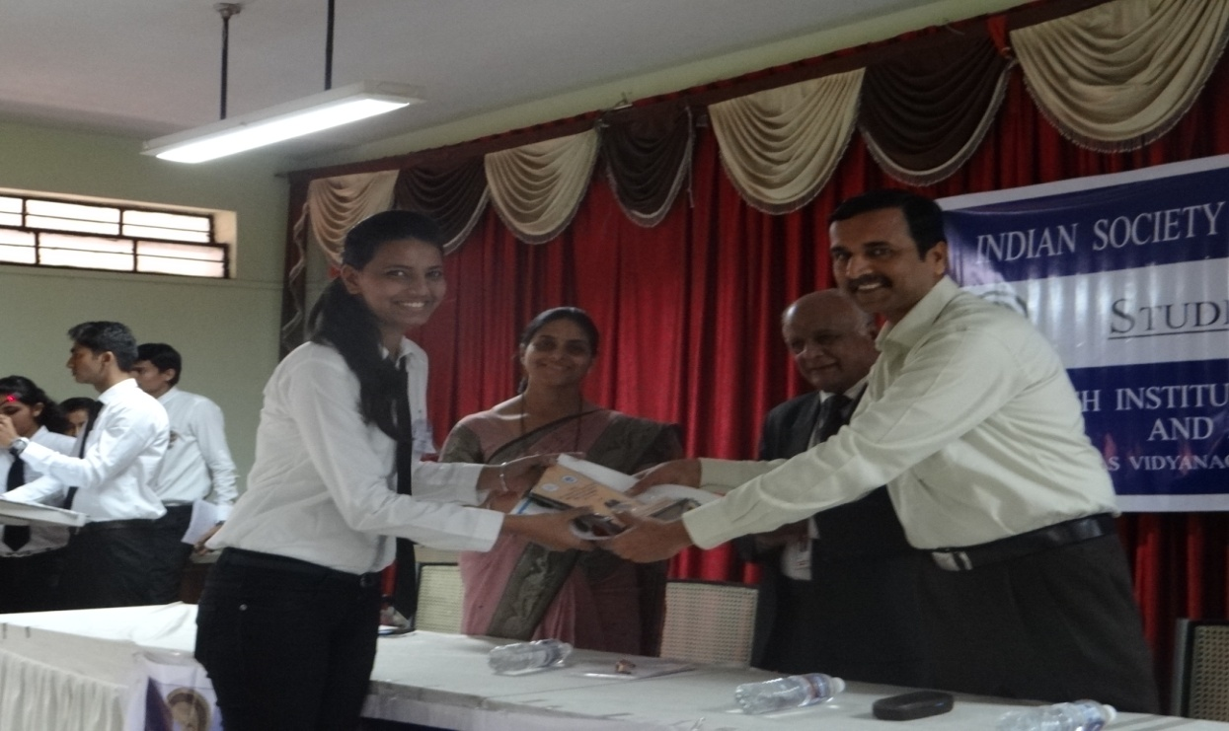

From L to R : Prof. P. S. Vispute, Prof. Vijay Bhat, Prof. Dr. K. N. Nandurkar with a speaker

- Master Student Program at Guru Gobind Singh College of Engineering, Nashik

The Master Student Program is organized every year in K. K. Wagh Institute of Engineering Education and Research by ISTE student’s chapter and this year it marked its 14th year of success. It was conducted not only in our college but also in Guru Gobind Singh College of Engineering on 22nd March 2016.
The theme of this year’s Master Students Program was “ENGINEER’s ARSENAL” introduced by principal of the institute Dr.K.N.Nandurkar. The program focuses on different skills an engineering student should acquire during four years of course to mould himself/herself as a world class professional. This theme is broadly classified into fourteen subtopics which were presented by fourteen students selected from various department of second year engineering as a speaker. They were mentored by a group of fourteen students from third year for a period of nearlytwo weeks. The speakers delivered a short presentation, each concentrating on the various facets of the given theme.
Prof. Dr. A. M. Chincholkar, Principal GCOREC, Mr. Parminder Kaur graced the event with their presence. Prof. Prajakta Vispute coordinated this event at GCOREC. The program was conducted for the entire day and it provided an entire spectrum of topics which includes 7 Hard and 7 Soft Skills, right from “Listening skills” to “Introspection” and “People skills”. Around 100 students of their college attended this program. Principal Dr.K.N.Nandurkar appreciated the efforts of our students and encourage the students to actively conduct this activity in other colleges also.
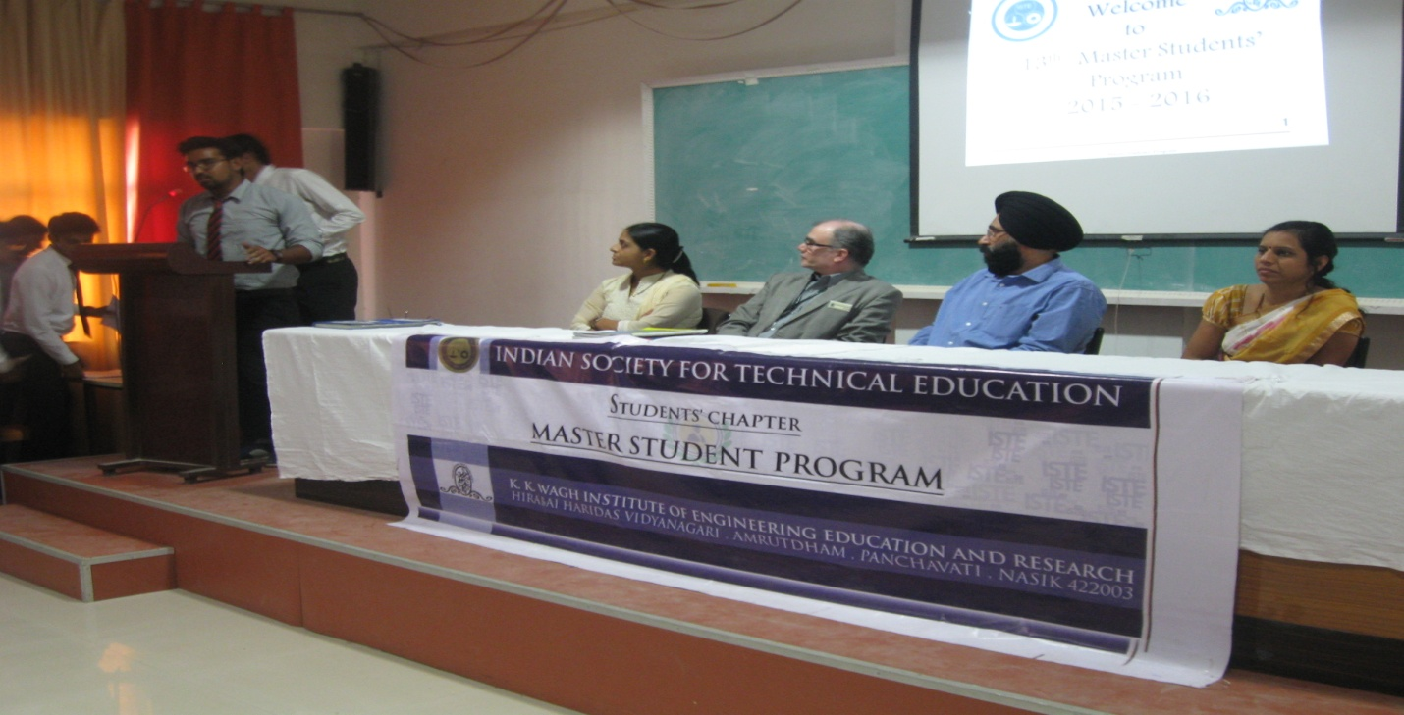
From L to R : Prof. P. S. Vispute, Prof. Dr. A. M. Chincholkar, Mr. Parminder Kaur, Mrs. S. Vispute

- Srinivasa Ramanujan Mathematics Competition Zonal and National Round

Srinivasa Ramanujan Mathematical competition held in K. K. Wagh Institute of Engineering Education & Research, Nasik on 27th March 2016. 67 students of Engineering and polytechnic and 2 staff members appeared for this exam. The online test was conducted between 10.am to 3.00pm in Dr. A.P.J. Training Center. After successful conduction of the test the results were uploaded on ISTE, New Delhi website. Prof. Dr. K. N. Nandurkar has reviewed the event and motivated the students for this competition. Prof. P.S. Vispute and Mr. Tile conducted this exam with the help of ISTE Students’ chapter student’s volunteers.

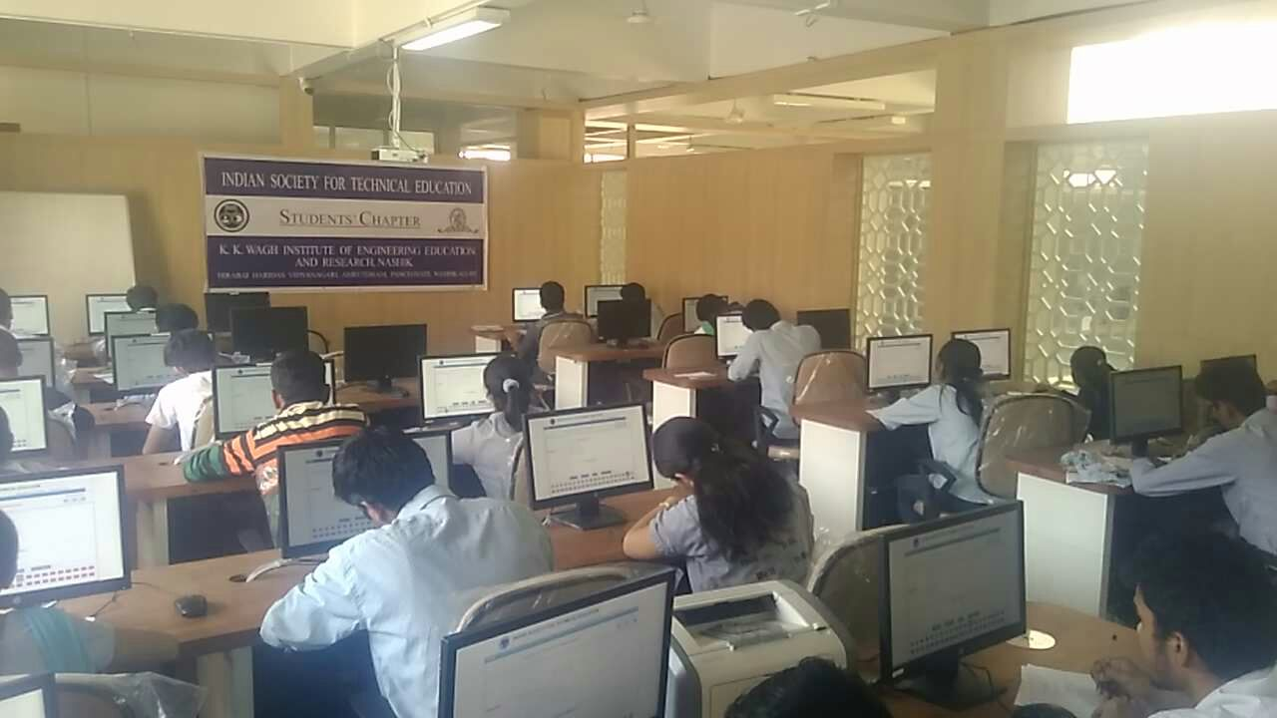
Participants of the SMRC

